PROPOSAL TO DISCONTINUE
THE ±1% PEAK EFFICIENCY TURBINE OPERATING LIMIT

Executive Summary

The NMFS 2000 Biological Opinion includes the requirement that turbine operations be limited to with ±1% of peak efficiency based upon the belief that the highest turbine passage survival occurs at highest efficiency. However, new data and a recent review of the original data cause Bonneville to believe that this turbine operating limit should be lifted. Bonneville proposes to discontinue the ±1% peak efficiency limit at McNary during the 2003 migration season, which includes baseline project survival research. Barring any problems encountered during the 2003 season at McNary, Bonneville proposed to discontinue the turbine operating limit at all of the mainstem federal projects during the 2004 migration season and beyond.

Milo Bell’s compendium, which is the main document cited in establishing the ±1% peak efficiency rule, does not appear to contain data to support the hypothesis that the highest survival occurs when operating turbines at peak efficiency. In summary, Bell’s compendium includes data on survival versus wicket gate opening from two Francis-unit projects. These data are somewhat scattered and do not support the conclusion that maximum fish passage survival occurs at peak efficiency. Bell’s compendium also includes data on survival versus efficiency for two projects with Kaplan units, but this data is also scattered and does not support the hypothesis that maximum fish passage survival occurs at peak efficiency. This information is described in more detail in Part 1 of this proposal.

Recent data indicate that high survival or even peak survival can be achieved outside of the ±1% peak efficiency range. The McNary 2002 turbine survival test and the Skalski et al article in the North American Journal of Fisheries Management have been summarized in Part 3 of this document. These two documents have been developed since the 2000 Biological Opinion consultation and are the reason Bonneville took the initiative to review all data pertaining to the ±1% peak efficiency operating rule. Bonneville believes that this new information combined with a thorough review of the historic data provides enough information to discontinue to the turbine operating limit.

The ±1% peak efficiency rule causes lost generation opportunities in certain hydrologic circumstances, which costs the Bonneville Power Administration and the region’s ratepayers significantly. This year, which is a relatively dry volume runoff year, approximately $5 million in generation revenues could be gained by allowing McNary Dam to operate outside of ±1% peak efficiency. The 50-year average cost of the ±1% peak efficiency rule at McNary is approximately $12 million ($ 0-26 million range) with the majority of the cost occurring in the summer and a significant part of the cost occurring in the spring. Additional costs of the ±1% peak efficiency rule could be recovered by allowing all of the mainstem FCRPS projects to operate outside of 1% peak efficiency. Additional information on the cost of the ±1% peak efficiency rule at McNary and generation limitations at other projects is provided in Part 3 of this proposal.

Based upon a Simpass analysis, there appears to be little or no risk that discontinuing the ±1% peak efficiency limit will decrease McNary’ project survival. All of the scenarios analyzed have an estimate project survival of 97.5 % ± 0.3 %. This information is presented in Part 3 of this proposal.

PROPOSAL TO DISCONTINUE
THE ±1% PEAK EFFICIENCY TURBINE OPERATING LIMIT

PHASE I. Allow McNary operations outside of ±1% peak efficiency during the 2003 migration season, which includes a baseline project survival study starting at McNary on April 28, 2003. During the project survival study, operate continually outside 1% to establish a consistent baseline condition.

PHASE II. Discontinue the ±1% peak efficiency turbine operating limit basin-wide based upon rationale described in this paper and based upon the 2003 McNary study finding no significant problems with the operation.

RATIONALE. New information, which was developed after the consultation for the current Biological Opinion, indicates that the basis for this operating rule is highly questionable. Additionally, new research results indicate that at McNary Dam there may actually be a survival benefit to operating outside of +1% peak efficiency. This information is presented in this document in three parts.

Part 1 includes information from documents supporting the ±1% Peak Efficiency Turbine Operating Rule and point out the weakness in the supporting information.

Part 2 includes information from post-2000 documents that raise questions about the ±1% peak efficiency turbine operating rule.

Part 3 includes the main reasons for discontinuing the ±1% peak efficiency turbine operating rule.

Part 1. Documents Supporting the ±1% Peak Efficiency Turbine Operating Rule

A. NMFS Biological Opinions

In the National Marine Fisheries Service December 2000 Biological Opinion titled “Reinitiation of Consultation on Operation of the Federal Columbia River Power System, Including the Juvenile Fish Transportation Program, and 19 Bureau of Reclamation Projects in the Columbia Basin,” the RPA says the following.

“The Corps and BPA will operate turbines within 1% of peak efficiency during the juvenile and adult migration seasons…”
“Operating turbines at peak efficiency is believed to provide the highest survival of anadromous species during passage through a turbine (Bell et al. 1981, Eicher 1987).”

B. Milo Bell’s Compendiums

Milo C. Bell et al’s May 1967 and September 1981 reports, both titled, “Compendium on the Success of Passage of Small Fish Through Turbines,” present published and unpublished data on tests of survival of small fish passing through turbines. Most if not all of the statements and figures from Milo’s compendium pertaining to the hypothesis that peak turbine passage survival occurs when operating turbines at peak efficiency are included in this paper.

On the study of Cushman Dam, Milo et al says the following.

“Plots 14, 15, 16 and 17 give corrected percent survival plotted at related wicket gate openings. The tests for 1960 and 1961 suggest a decreasing survival on either side of approximately 0.8 gate opening. Part of the scatter can be accounted for by the variability in the tailwater elevations among the various runs.”

Cushman has Francis units; therefore the results of this study are not applicable to projects with Kaplan units. Nevertheless, it is noteworthy to read this statement and look at Figures 1 through 4, which include plots 14 through 17 from Bell’s report. Bell’s conclusion that peak survival occurs at the 80% gate opening is questionable and not well supported by the data. Based on visual observation, the highest survival does not appear to occur at 80% wicket gate opening in plots 14, 15, 16, and 17. Bell’s report does not explain how he reached this conclusion and does not include a numerical analysis of the data.

Figure 1. Plot 14 from Milo Bell's Compendium. “(y vs. x) corrected percent survival versus wicket gate opening, Cushman, 1960.”
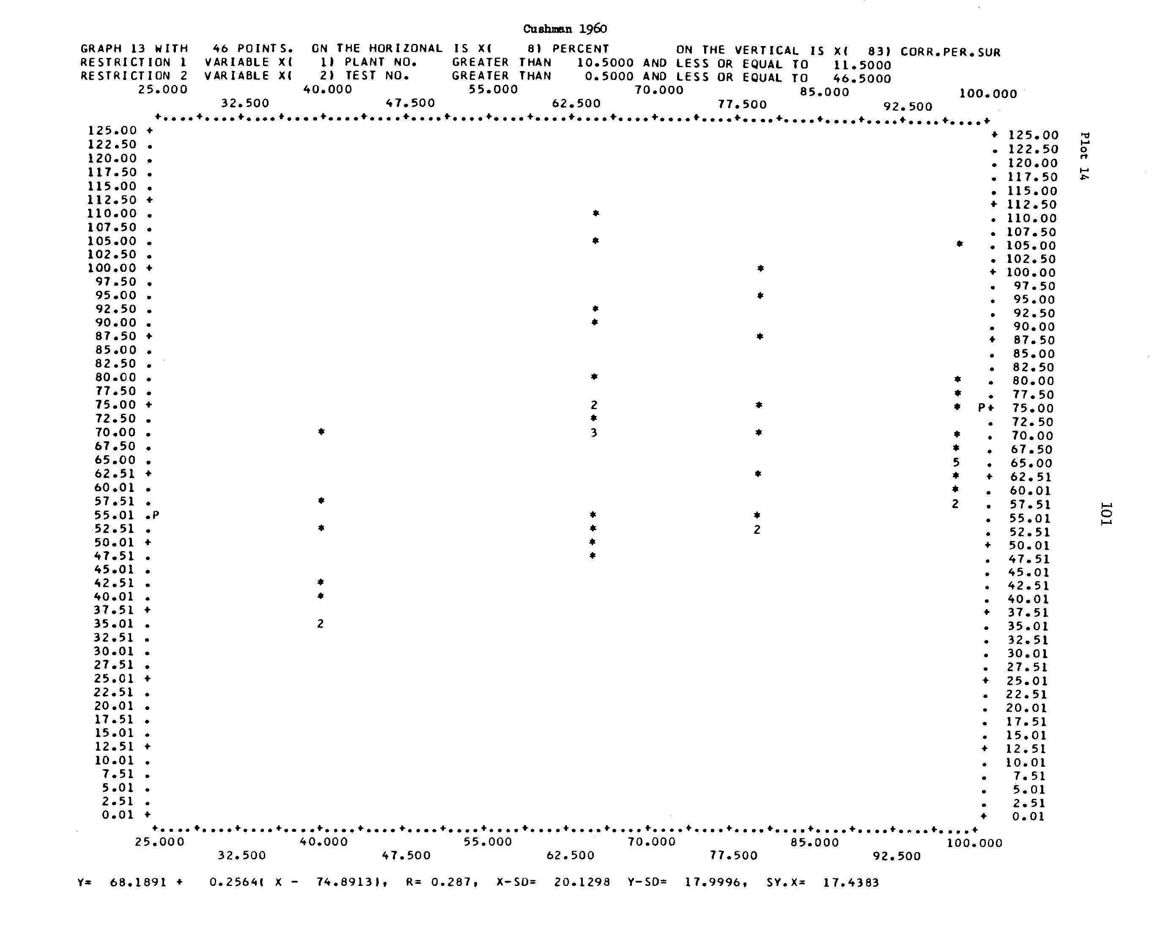

Figure 2. Plot 15 from Milo Bell's Compendium, “(y vs. x) corrected percent survival versus wicket gate opening, Cushman, 1961.”
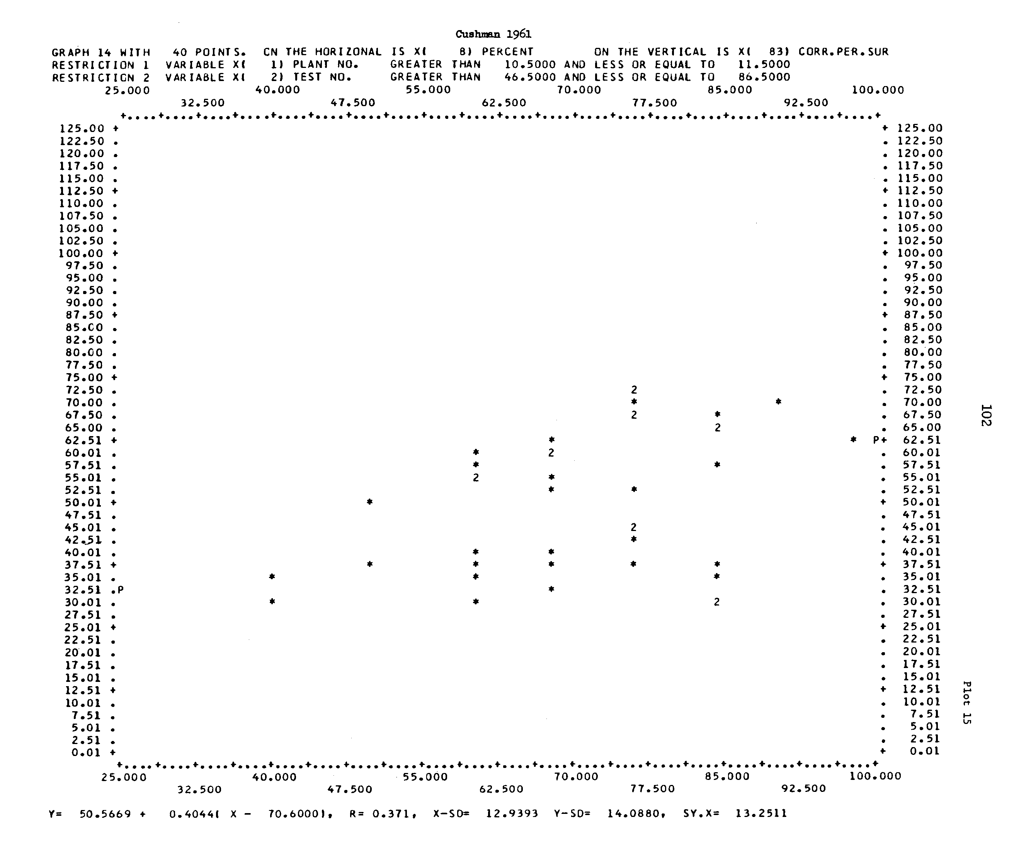

Figure 3. Plot 16 from Milo Bell's Compendium, “(y vs. x) corrected percent survival versus wicket gate opening, Cushman, 1961 – steelhead only.”
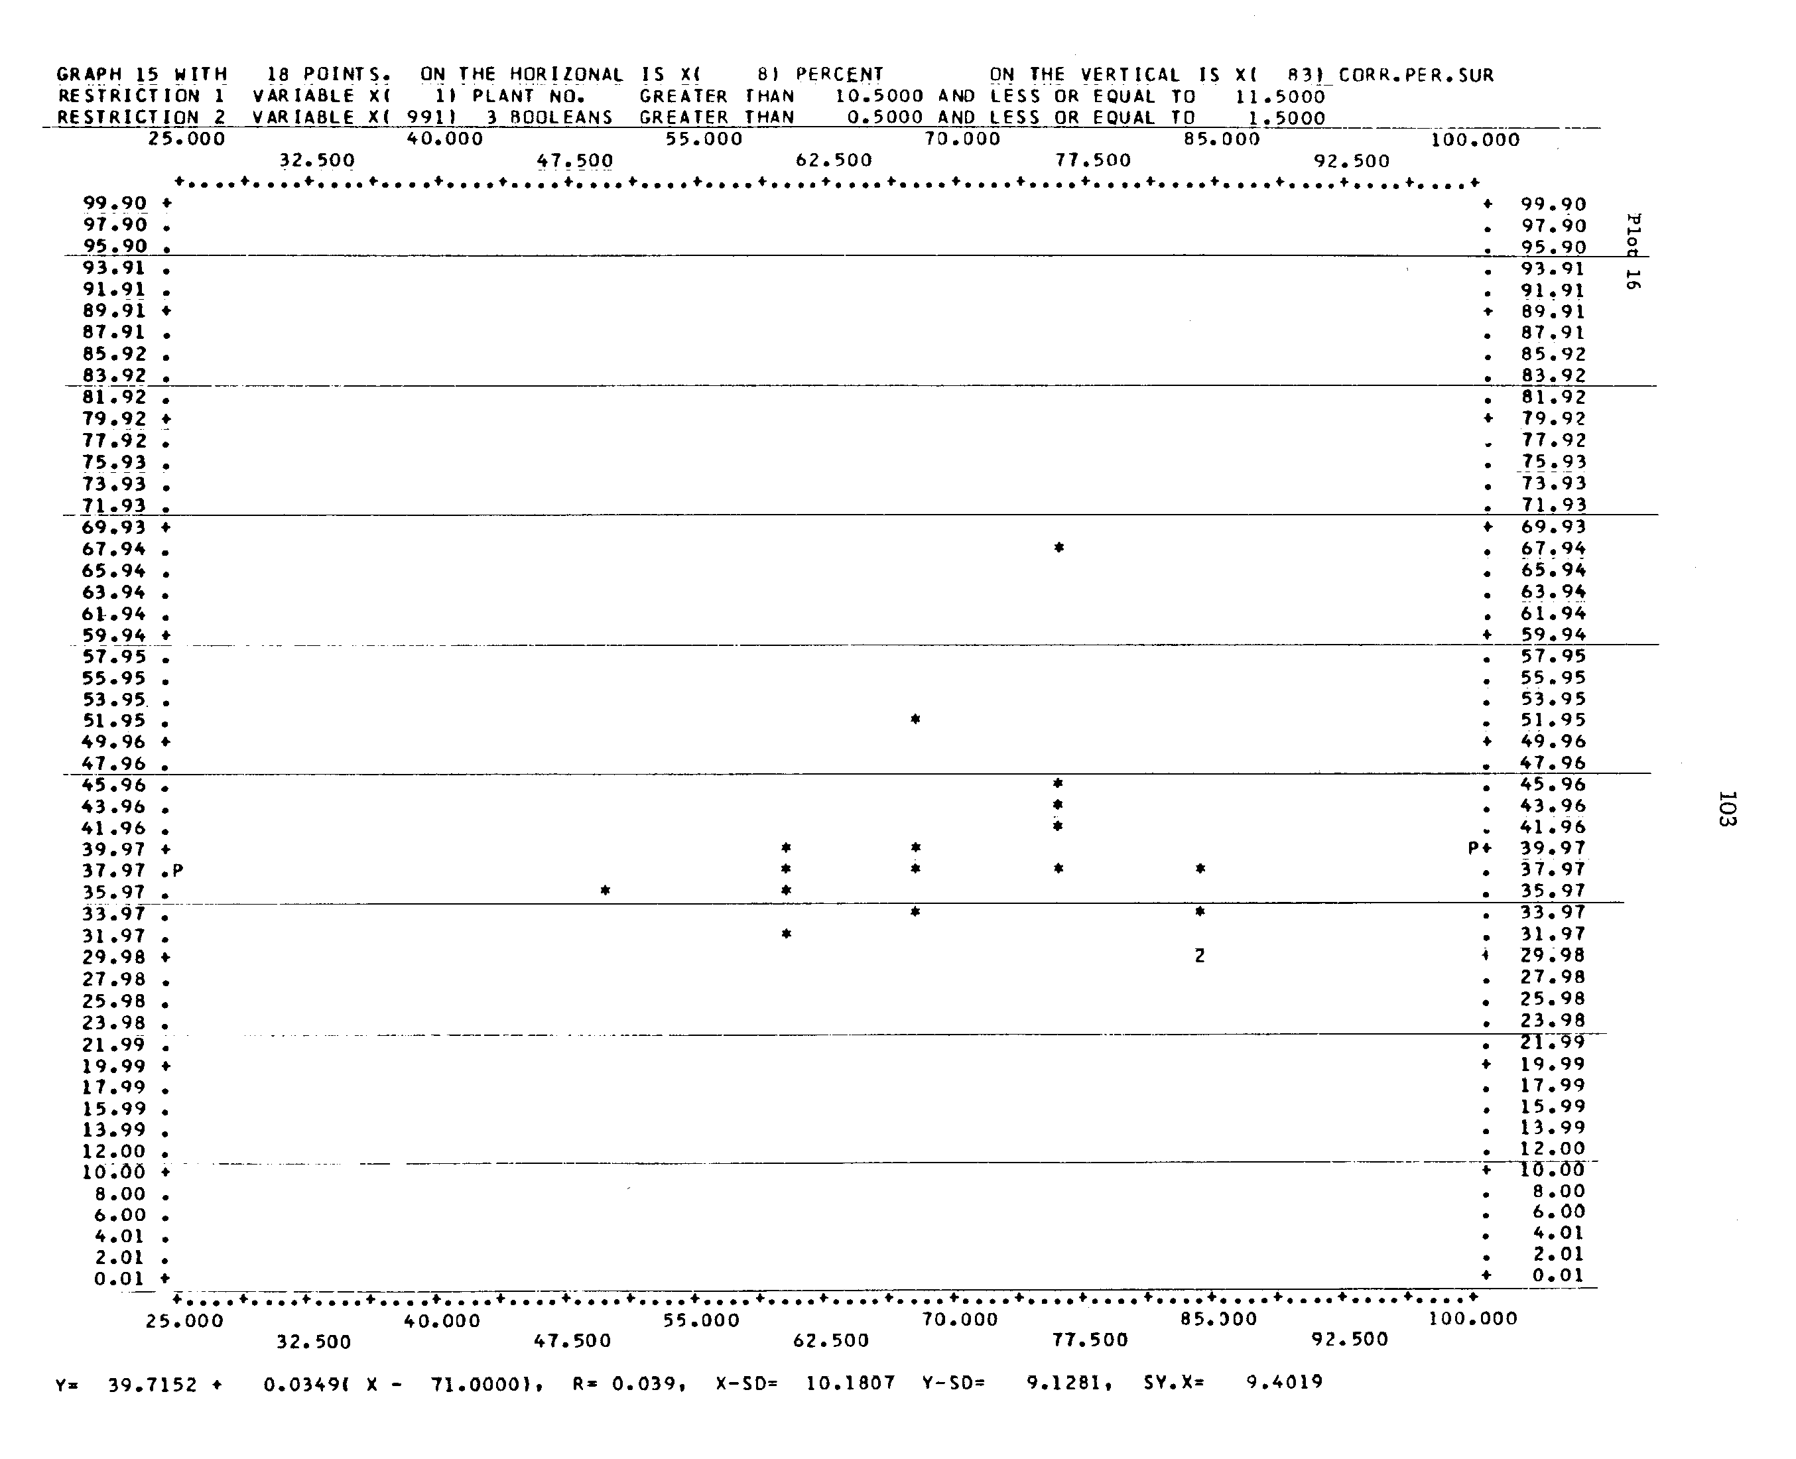

Figure 4. Plot 17 from Milo Bell's Compendium, “(y vs. x) corrected percent survival versus wicket gate opening; All Cushman.”
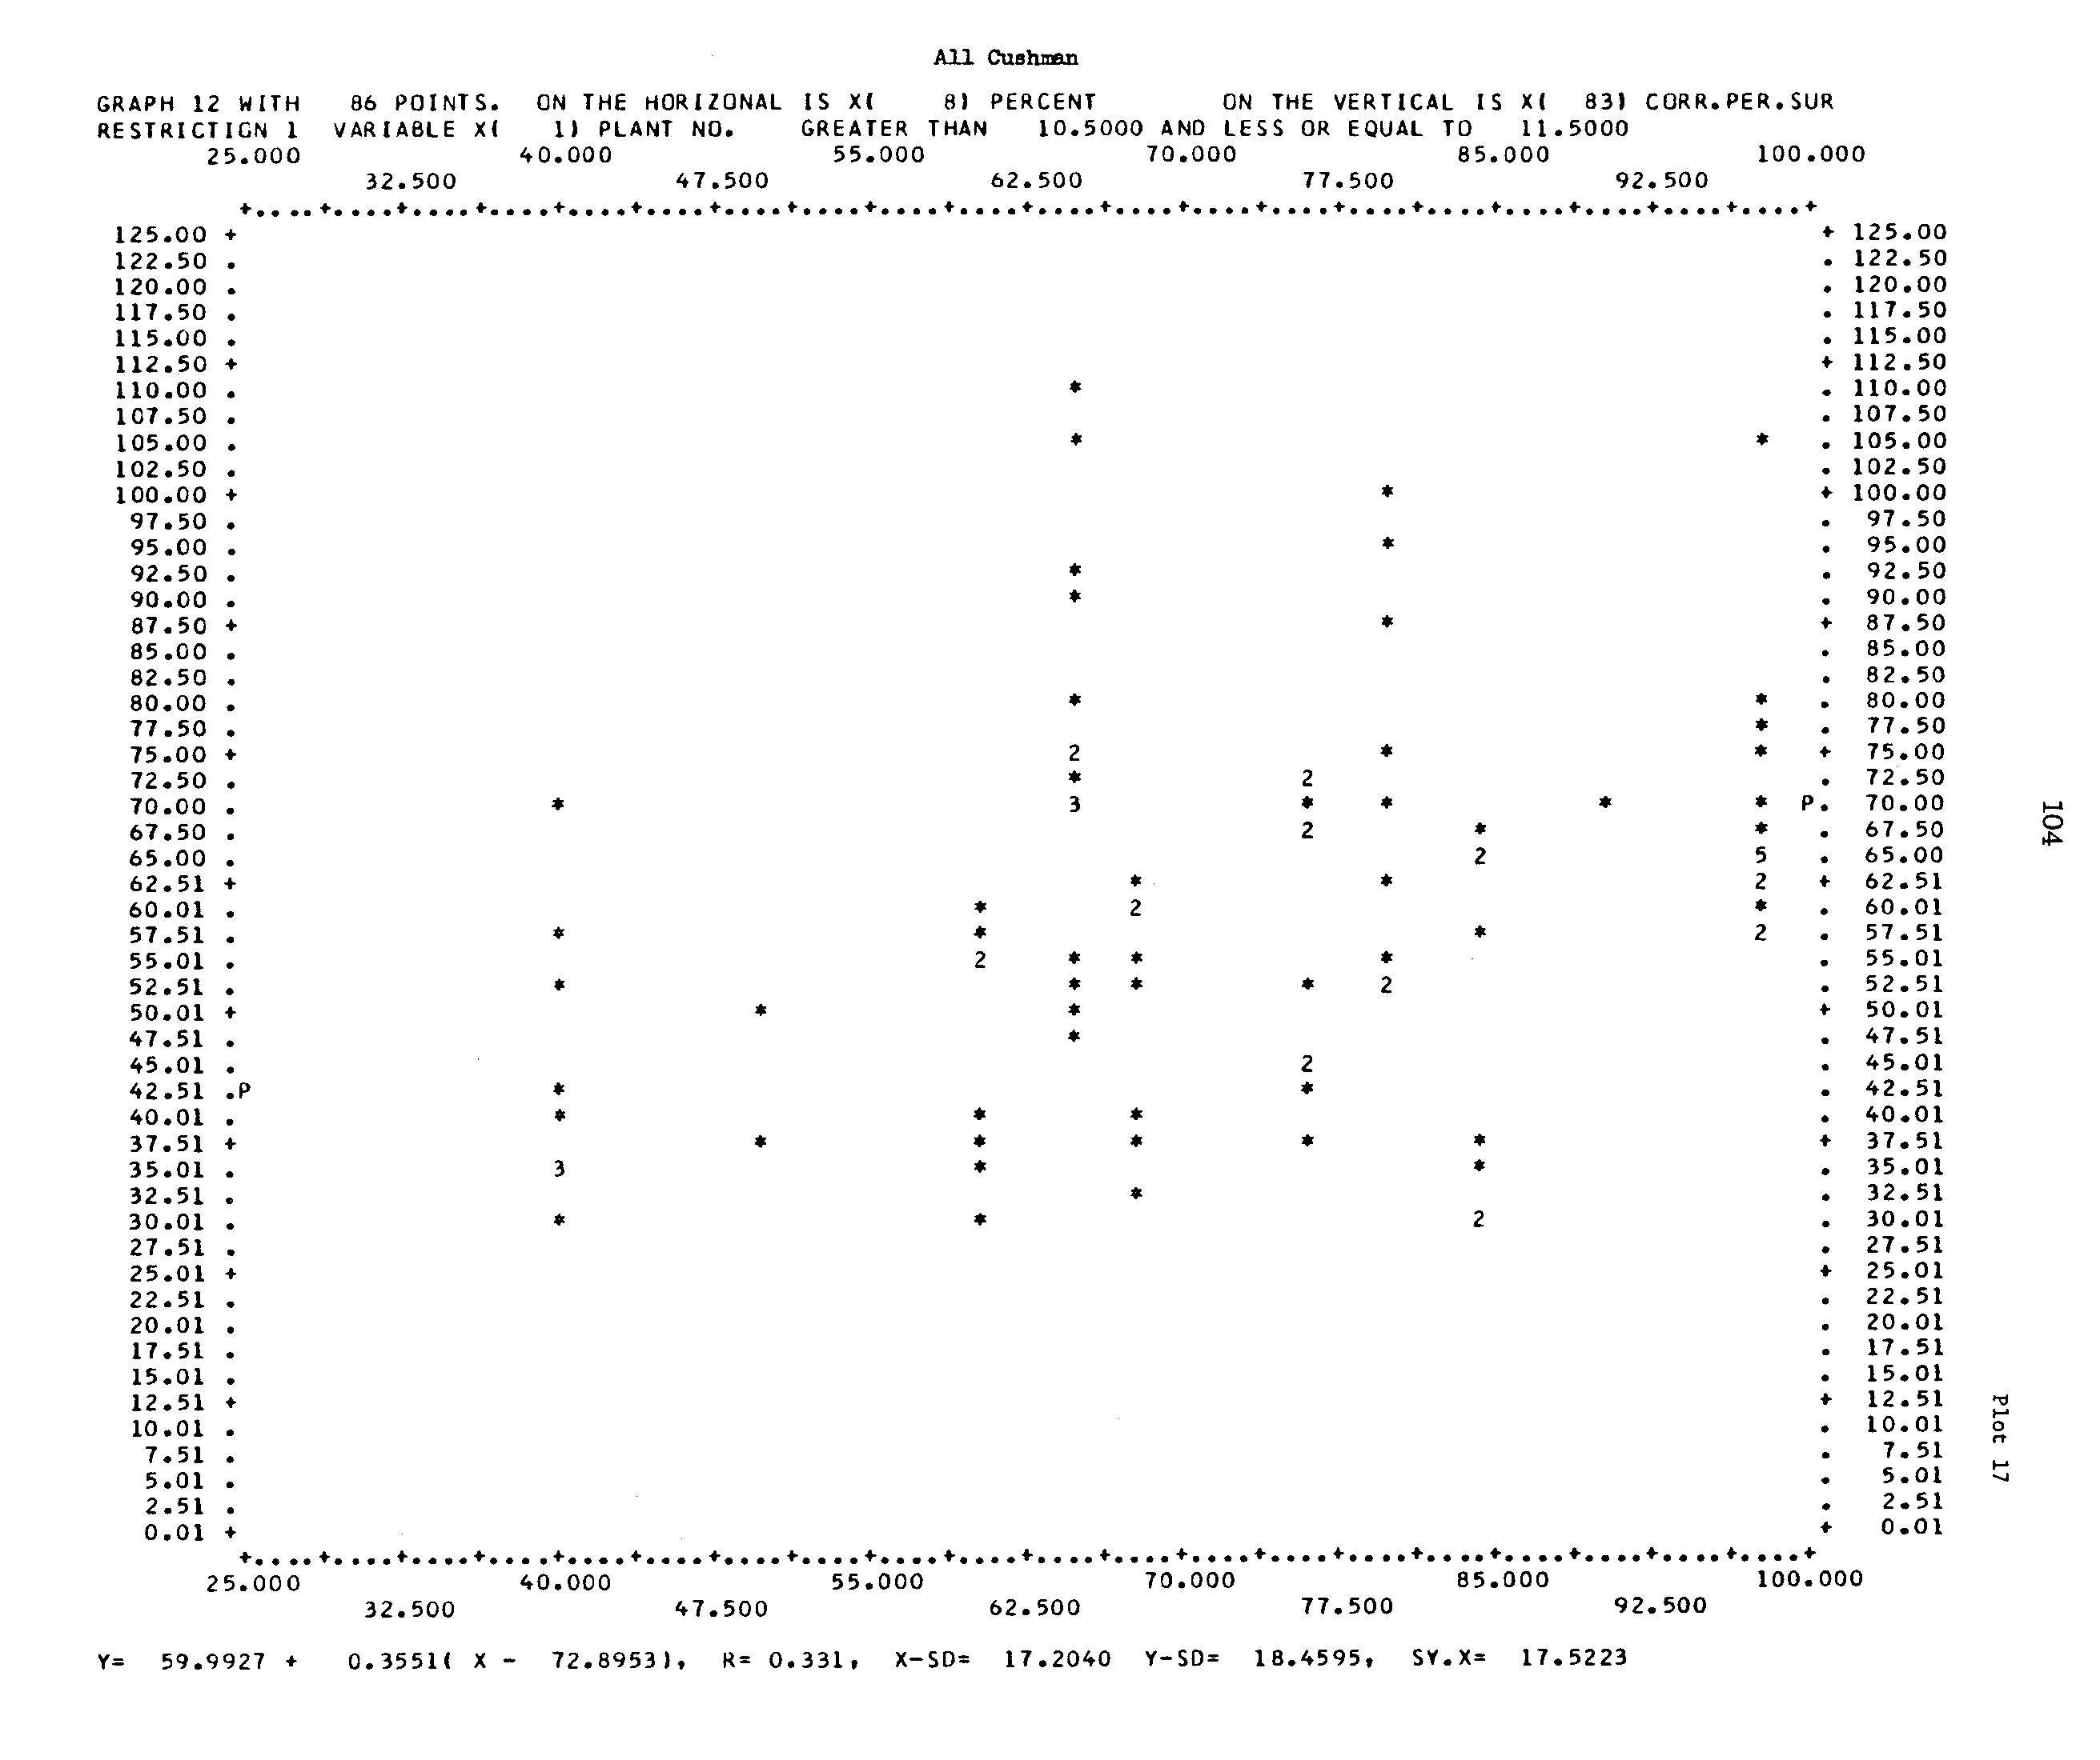

“Plot 39 relates wicket gate opening to corrected percent survival and indicates that at approximately 0.6 gate opening a better survival rate was realized. The number of tests and their widely scattered nature precludes a precise statement concerning this relationship for a series of tests.”

“In Plot 40 the relationship between survival and wicket gate opening can be established only by using mid-points for the various runs. The individual test points are widely scattered. In plot 41, the combined data require again the use of averages for the various runs to establish the relationship. The pooled data do indicate, however, that openings of approximately 0.6 gave the maximum survival.”

Shasta also has Francis turbines, which means that these study results are not applicable to projects with Kaplan units. Again, it is interesting to look at the conclusions drawn from the figures. The conclusion that peak survival occurs at a 60% gate opening is questionable and not well supported by the data. There seems to be only one data point in Plot 39 that supports this conclusion. Bell does state that the data is scattered and precludes a precise conclusion.

Figure 5. Plot 39 from Milo Bell's Compendium, “(y vs. x) corrected percent survival versus wicket gate opening; Shasta – chinook.”

Figure 6. Plot 40 from Milo Bell's Compendium, “(y vs. x) corrected percent survival versus wicket gate opening; Shasta – rainbow and steelhead.”
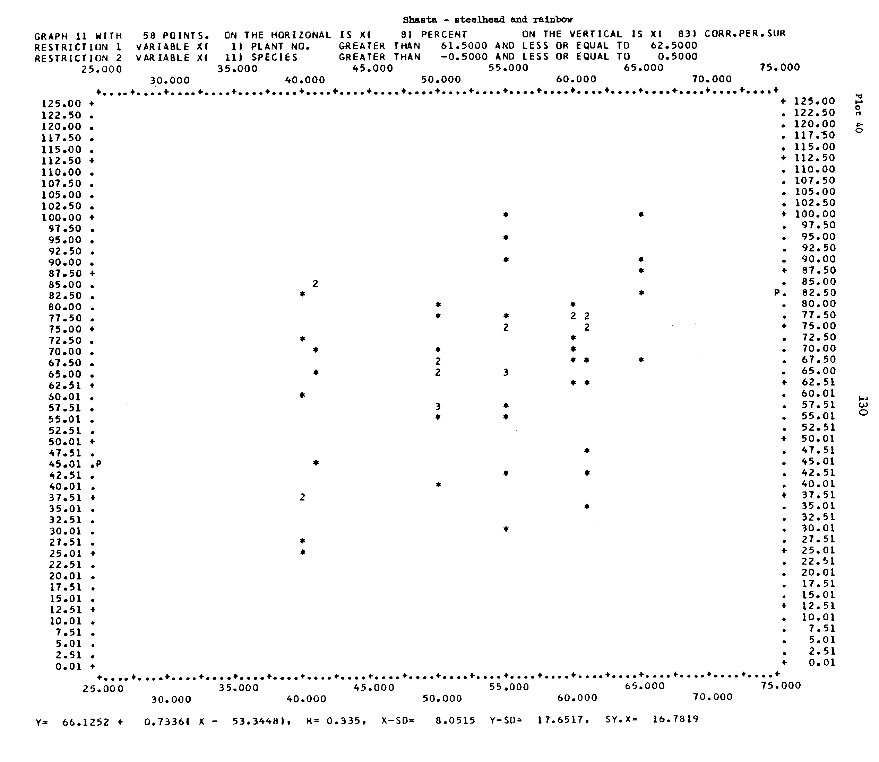

“Corrected percent survivals and wicket gate opening values are given in plots 72, 73 and 74. In both plots 72 and 73 any relationship is difficult to establish due to the scatter of the points, the apparent absence of a clear trend. There is a weak indication that the best passage may be at about a gate opening of 0.6 to 0.7. In plot 74 the combination of data points for the two years masks out any particular relationship. There does not seem to be a smooth ascending and descending curve following the efficiency line of the turbines as might have been expected. The data offer some support, however, to the hypothesis that the best points of machine efficiency should give the best points of fish passage survival.”

Big Cliff has Kaplan units. Therefore these study results may be applicable to the mainstem FCRPS projects. However, Bell’s conclusion about the data is highly questionable again. Bell et al states that the best passage might occur at a 60-70% gate opening and that the data support the peak efficiency hypothesis. Bell et al’s data plots are included in Figures 7 though 9. Bell’s conclusions are simply not supported by the data, which is somewhat scattered and lacking a clear point of peak survival. Skalski et al’s (2002) comments on this conclusion are included in section 2A of this paper.

Figure 7. Plot 72 from Milo Bell's Compendium, “(y vs. x) corrected percent survival versus wicket gate opening; Big Cliff, 1964.”
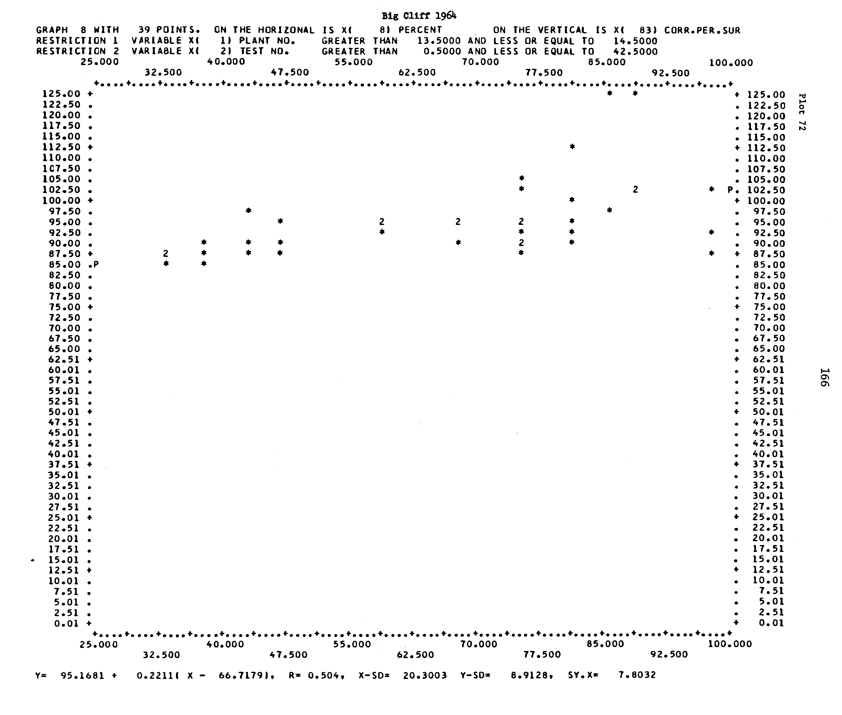

Figure 8. Plot 73 from Milo Bell's Compendium, “(y vs. x) corrected percent survival versus wicket gate opening; Big Cliff, 1966.”
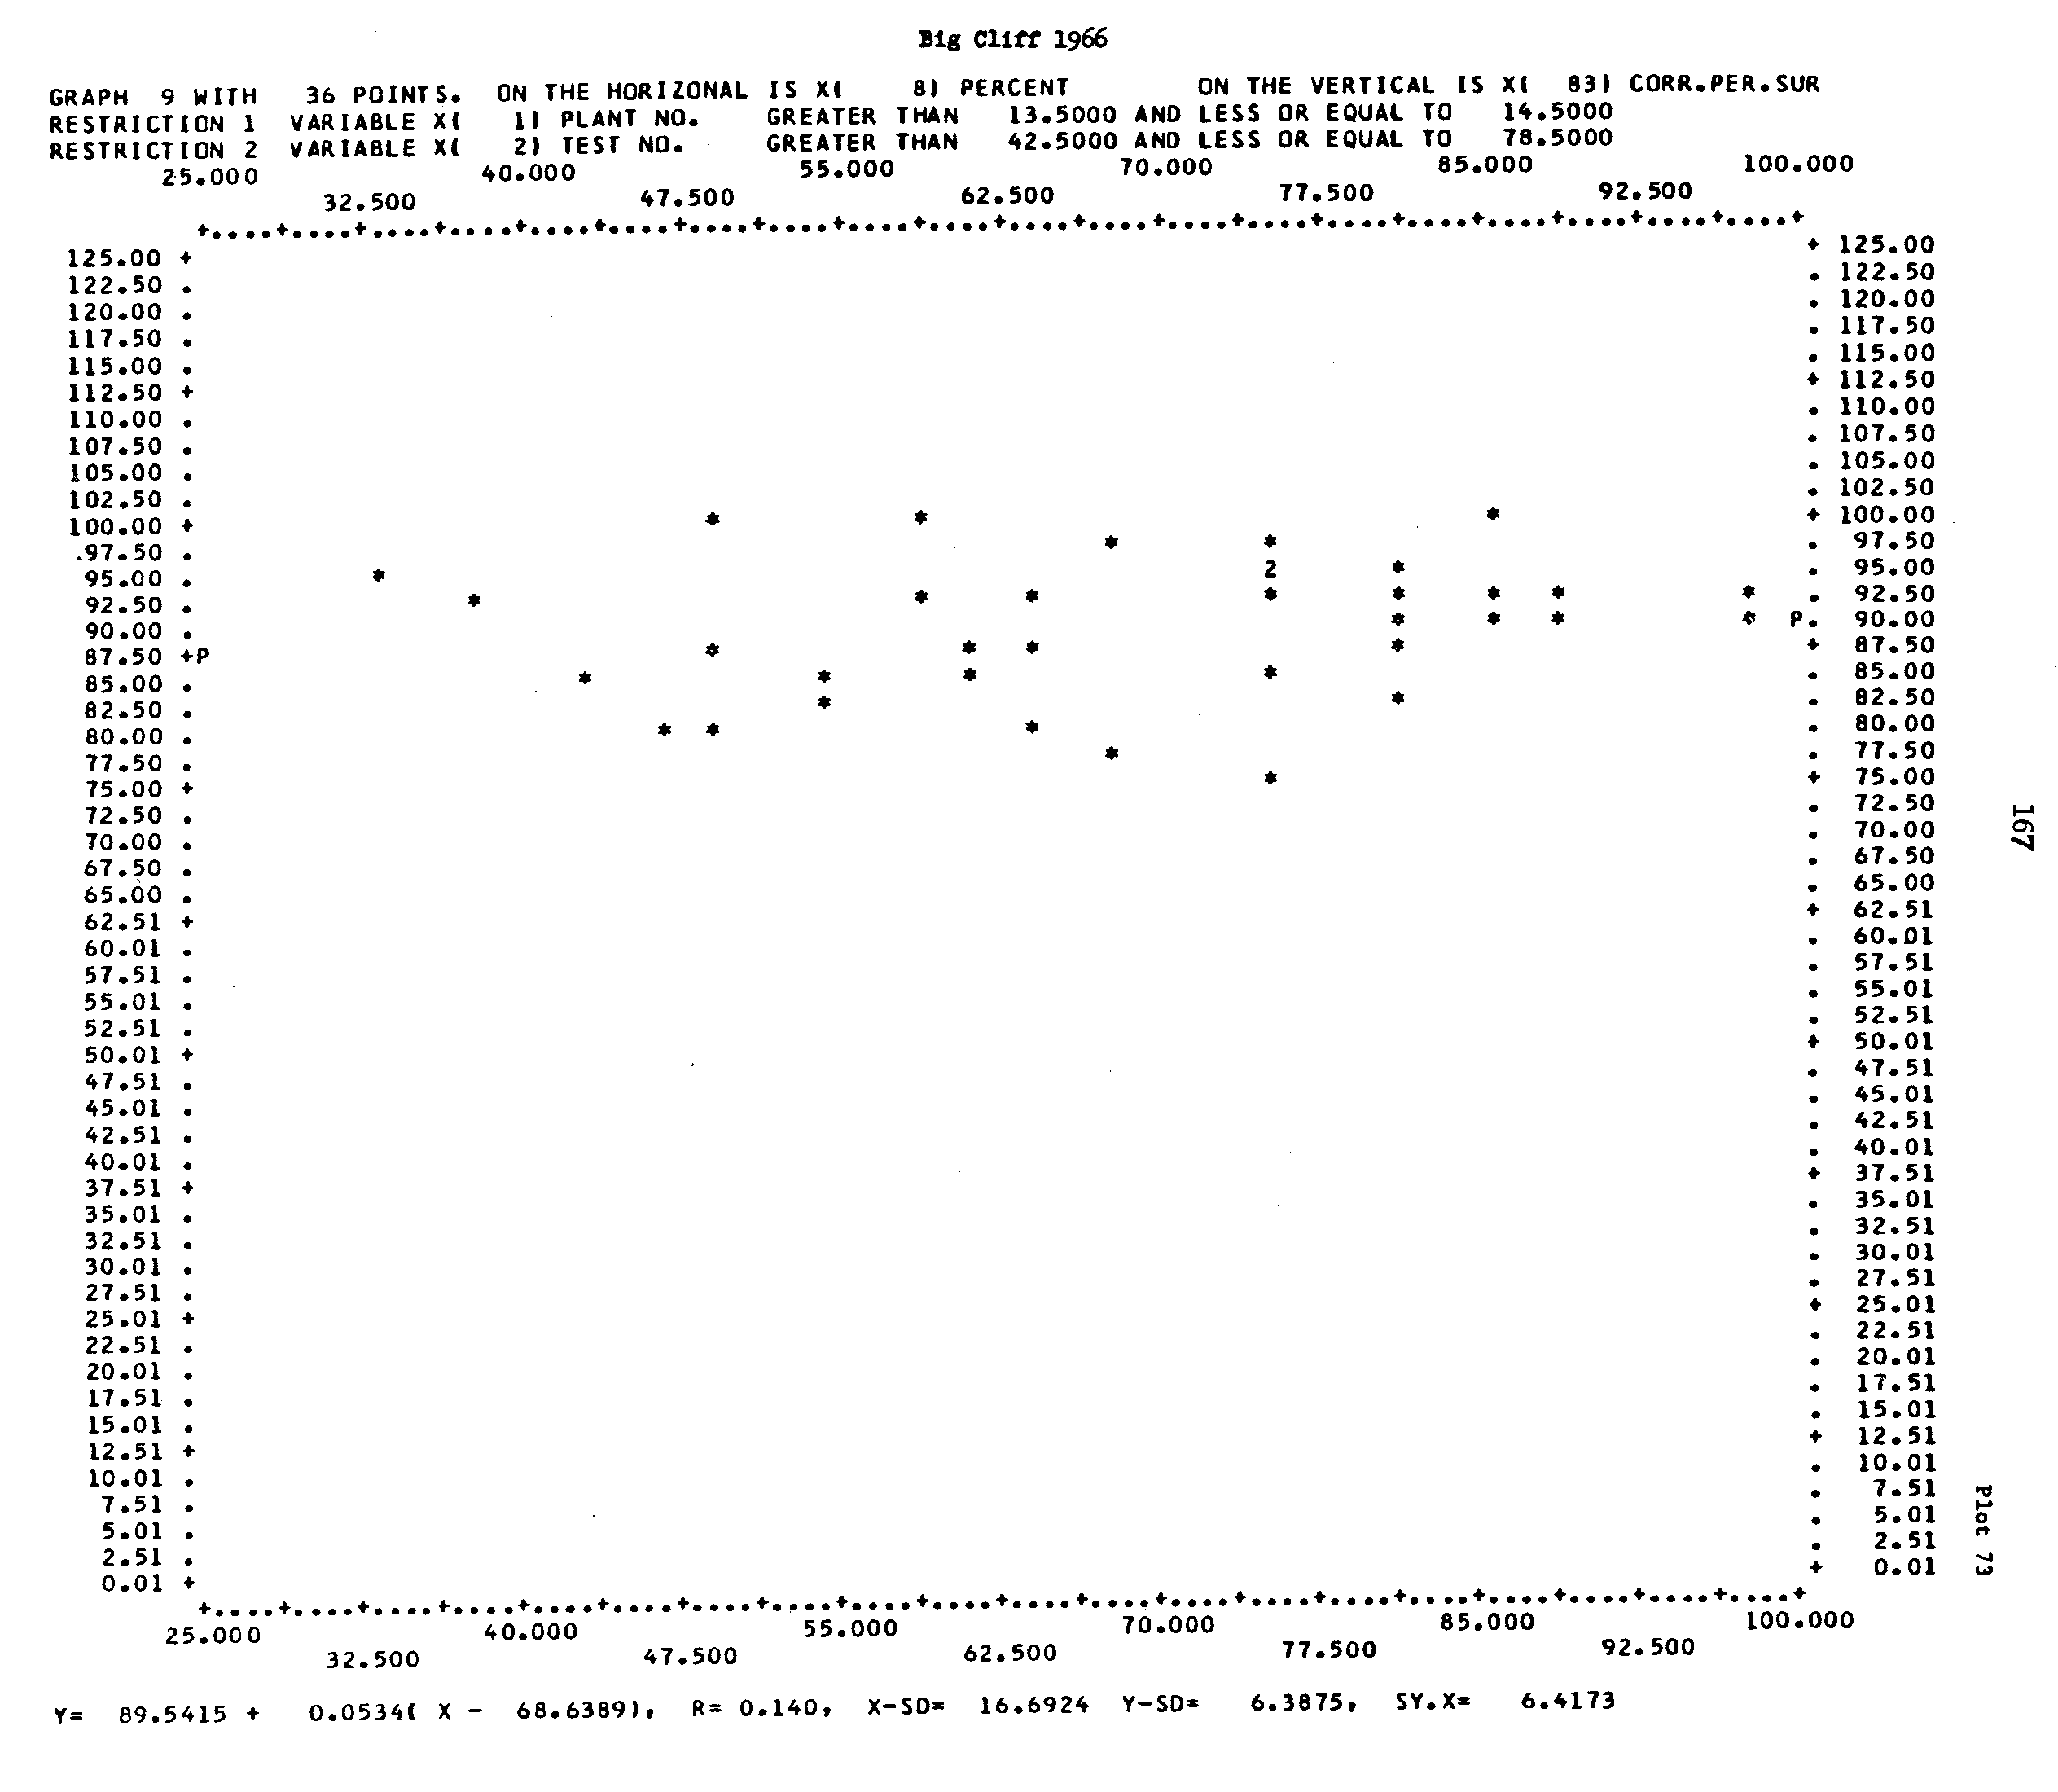

Figure 9. Plot 74 from Milo Bell's Compendium, “(y vs. x) corrected percent survival versus wicket gate opening; All Big Cliff.”

Foster Dam is another project with Kaplan units that is presented by Bell et al in support of the peak efficiency hypothesis. Milo C. Bell’s September 1981 “Updated Compendium on the Success of Passage of Small Fish Through Turbines” says the following:

“In Section III the turbine efficiency, plant sigma, and runner sigma are shown in graphic form as related to discharge through a unit. For the purpose of this analysis, these have been extracted and the resulting survival figures added to relate the success of fish passage to these conditions (Exhibits 19-21). As would be expected, the turbine efficiency is shown to be the highest at the best designed conditions and generally, again, it was found that fish passage success follows turbine efficiency.”

“The Foster data as shown on Exhibits 19-21 demonstrate that there were deviations in the above-stated relationships that best fish passage followed best turbine efficiency, and this relationship should be applied only when considering an average effect and used with discretion at a single point.”

“Generally, the points of highest turbine efficiency give the most efficient level for fish passage.”

Once again, Bell’s conclusions are questionable. In Exhibit 18, peak survival occurs at peak efficiency with the blade angle at 25% and 50%, but peak survival occurs above or below peak efficiency with the blade angle at 0%, 75%, and 100%. In Exhibits 19 and 20, peak survival occurs at peak efficiency for a 75% blade angle but not for the 0%, 25%, and 50% blade angles. In Exhibit 21, the 1964 data supports Bell’s conclusion, but the 1966 data is not as clear, and the 1967 data does not support the conclusion. (Note: Bell et al seems to mistakenly refer to data from Big Cliff Dam in Exhibit 21 in the discussion of Foster Dam data.)

Figure 10. Exhibit 18 from Milo Bell's Compendium
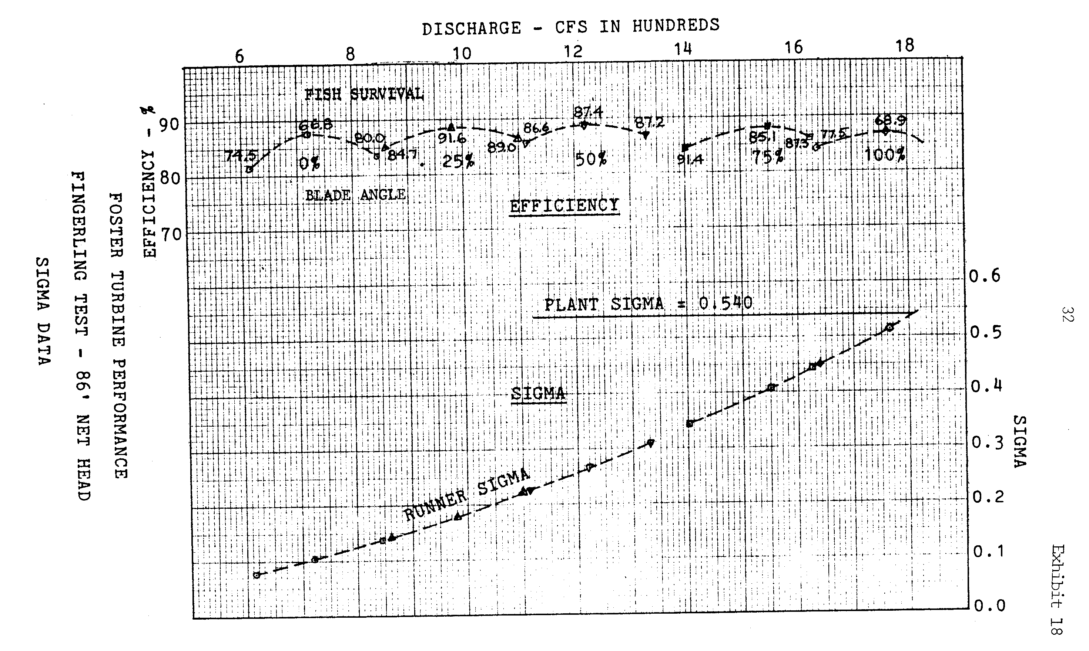
Figure 11. Exhibit 19 from Milo Bell's Compendium

Figure 12. Exhibit 20 from Milo Bell's Compendium
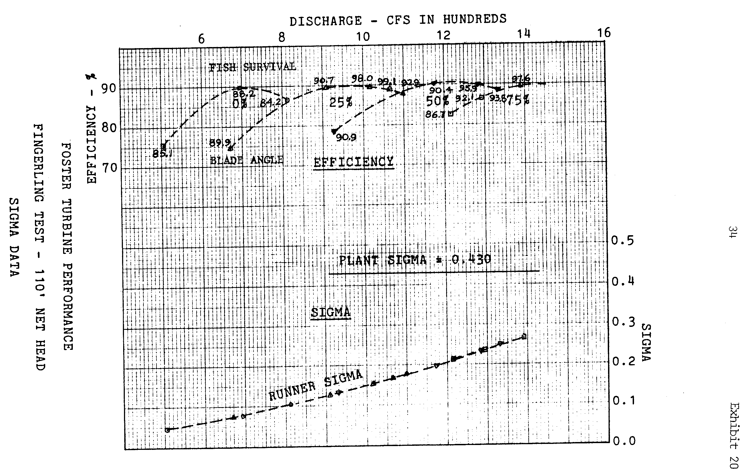

Regarding the 1967 Big Cliff study, another project with Kaplan units, Bell makes the following comments.

“It verifies the previous conclusions from other tests at Big Cliff that the efficiency of the turbine is a fair measurement for predicting the success of fish passage through large turbines.”

“The 1967 tests fortify the previous two series of tests and the position that the best efficiency of fish passage was obtained when the most water-efficient passage was available.”

The plots of Big Cliff survival data, Exhibits 21-23 from Bell’s compendium, are shown in Figures 13-15. Again, Bell’s conclusions are questionable. There are eleven sets of survival and turbine efficiency curves in Exhibits 21-23, each representing different project head and different years of study. Four of these curves show the peak survival and peak efficiency points aligned and support Bell’s conclusion; four disagree with the conclusion; the other three curves are inconclusive.

Figure 13. Exhibit 21 from Milo Bell's Compendium
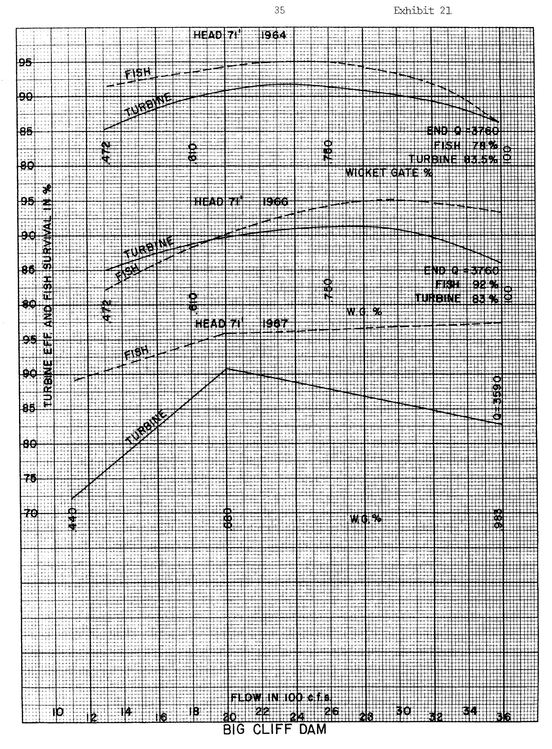
Figure 14. Exhibit 22 from Milo Bell's Compendium
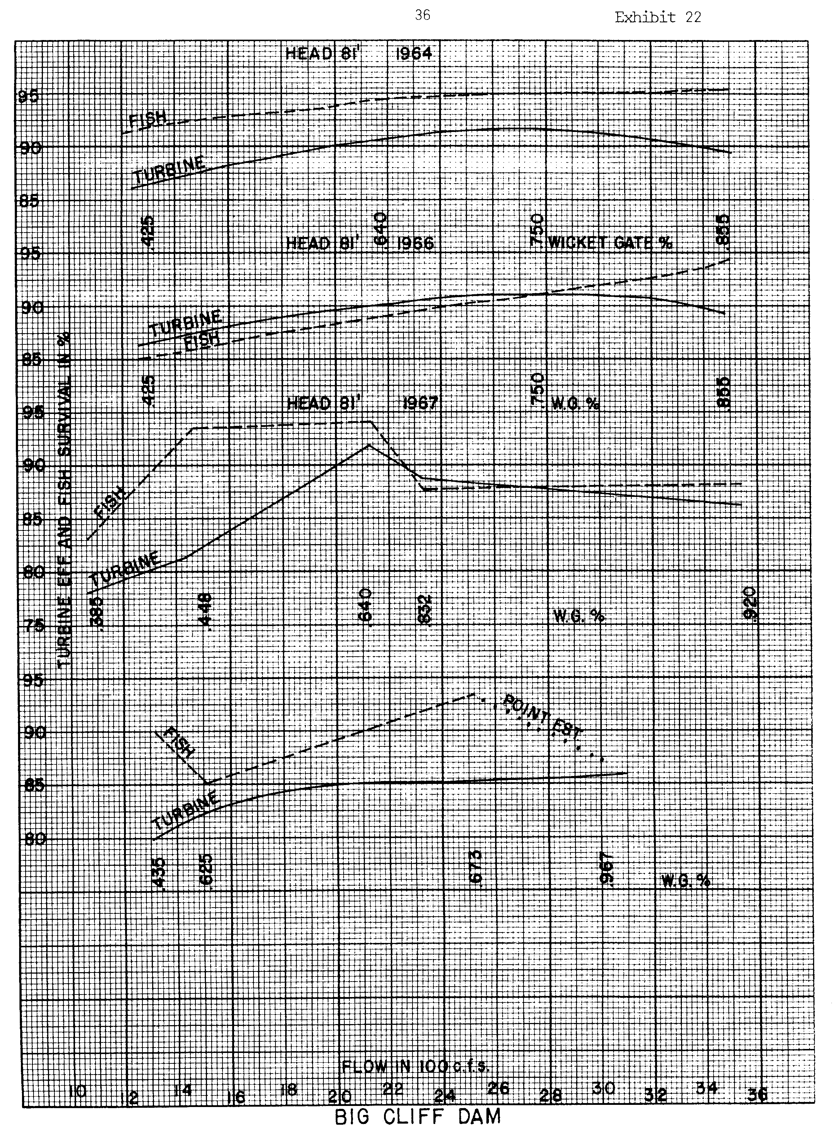
Figure 15. Exhibit 23 from Milo Bell's Compendium
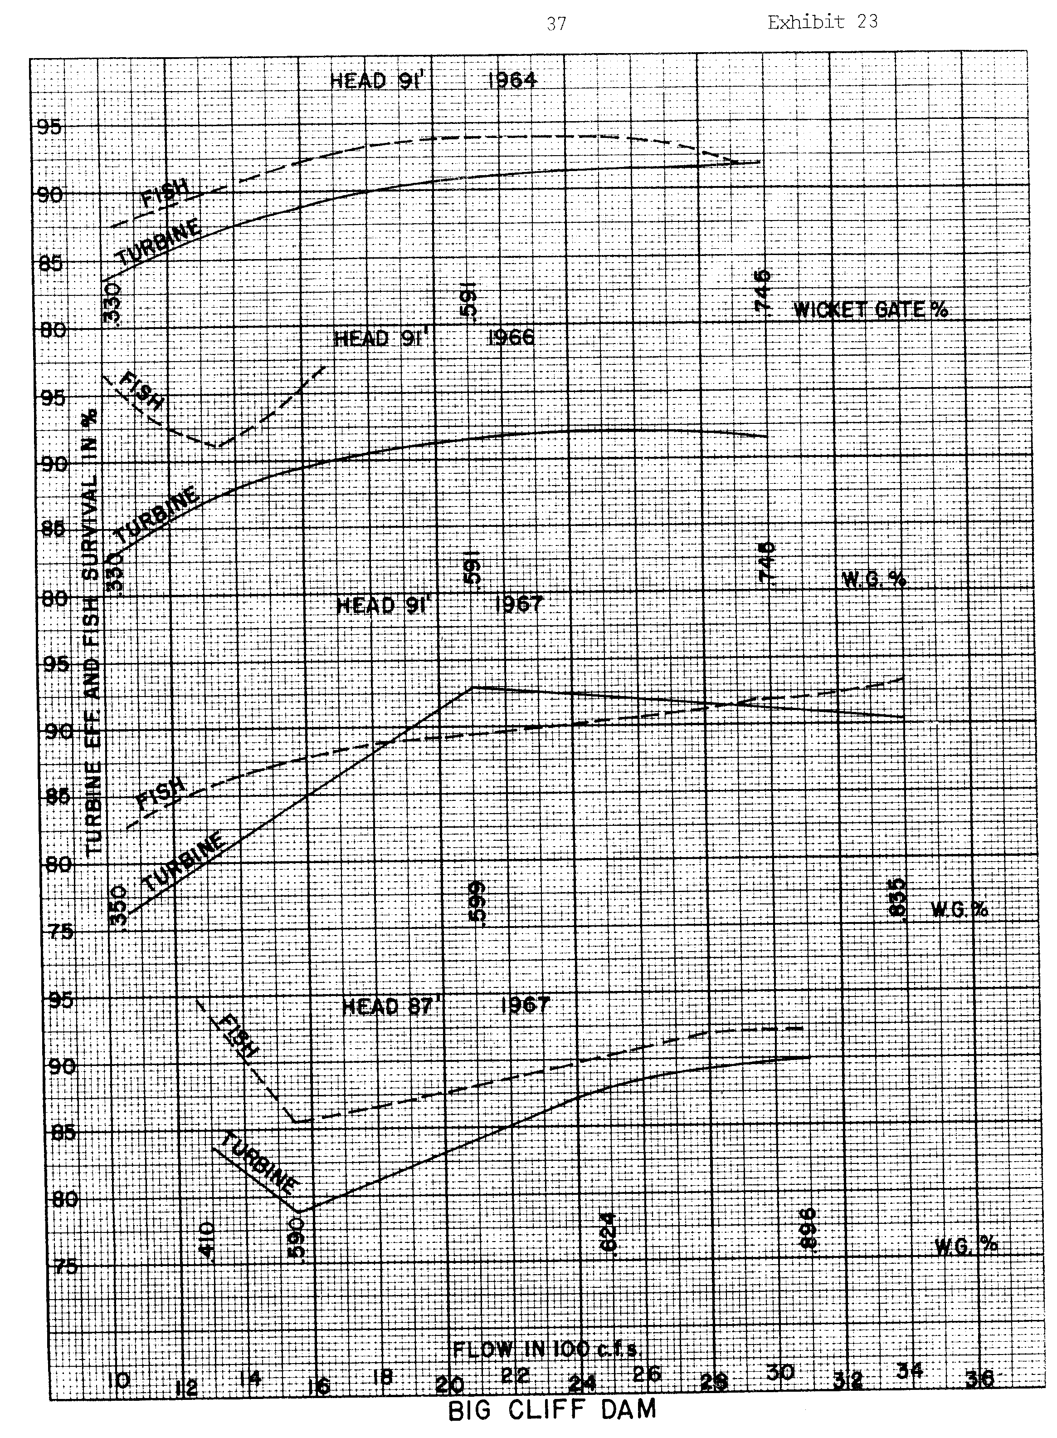
In summary, Bell’s compendiums include survival versus wicket gate opening data from two Francis-unit projects, Cushman Dam and Shasta Dam. These data do not show a strong, consistent correlation between wicket gate opening and survival, nor do they support the conclusion that maximum fish passage survival occurs at peak efficiency. Only the Foster and Big Cliff data show survival versus efficiency data, but still this data does not support the hypothesis that maximum fish passage survival occurs at peak efficiency. Nevertheless, this is the body of evidence that is cited as the basis for the ±1% peak efficiency operating limit.

C. Eicher’s 1987 “Turbine-Related Fish Mortality: Review and Evaluation of Studies”

One of Eicher’s objectives in this report was to critically review past turbine survival studies and to establish the credibility of past data. Eicher makes the following comments on the Foster Dam study reported in Milo Bell’s 1981 compendium.

“This appears to be a good test series with a total of 43 runs giving strong substance. Insufficient data are provided to adequately assess it, however.”

“Of five percentage gate openings tested (0-25-50-75-100), 50 percent proved most efficient with a mean of 87.8 ± 3.1. Greatest survival of fish, however, occurred at 25 percent gate opening and a mean efficiency of 85.7 ± 5.2 which is a departure from the norm of highest efficiency producing best survival.”

Additionally, Eicher makes the following comments on Oligeher and Donaldson’s 1965 turbine survival report on Big Cliff Dam.

“Turbine efficiencies and percent survival of chinook salmon are compared. They usually parallel each other; but too few points are available. Limited and sometimes opposite results limit conclusions.”

Eicher makes the following comments on Oligeher and Donaldson’s 1966 turbine survival report on Big Cliff Dam.

“Maximum survival generally occurred in the area of highest turbine efficiency with some exceptions”

“Survivals of about 95% were reported at best turbine efficiency…”

Based on Figures 13-15, Exhibits 21-23 from the Bell compendium, this statement appears to be true for the data at 71 feet of head but not true for the data at 81 and 91 feet of head.

Eicher makes the following comments on Wagner and Ingram’s 1973 turbine survival report on Foster and Green Peter Dams, which raises questions about any conclusions drawn from these studies.

“Assignment of turbine mortality was subjective because most mortality was due to capture nets.”

Eicher’s report also includes a discussion of factors affecting fish in passage through turbines, including efficiency. On the topic of efficiency, Eicher says the following.

“The efficiency at which a turbine converts water under pressure into mechanical energy is an indicator of other factors bearing on the amount of mortality of fish passing through turbines rather than being a factor in itself. It was generally agreed by all experts involved at a workshop on turbine mortality in 1984 (Eicher Associates, 1985A) that maximum survival of fish coincides with greatest turbine efficiency. At greatest efficiency, cavitation and related pressures are least prevalent and flows are smoother (Bell et al, 1967R). Comparisons of efficiency and mortality curves are imprecise because the curves are relatively flat without clear relationships with each other.”

Clearly Eicher’s conclusion that comparisons of efficiency and mortality curves are imprecise is supported by the data. However, Eicher’s report is another report commonly cited in support of the ±1% peak efficiency operating limit.

Part 2. Post-2000 Documents Raising Questions About the ±1% Peak Efficiency Turbine Operating Rule

A. The 2002 Skalski, Mathur, and Heisey Paper

In the North American Journal of Fisheries Management 2002 article, “Effects of Turbine Operating Efficiency on Smolt Passage Survival,” John R. Skalski, Dilip Mathur, and Paul G. Heisey analyzed data on the relationship between operating efficiency and passage survival through Kaplan turbines. The purpose of the investigation was “to reexamine the evidence presented in Bell (unpublished report) and compare it with more recent data generated by balloon-tag releases and recoveries of salmonids conducted by Normandeau Associates (1994-2000).” Skalski et al found the following.

“Despite the many comparisons performed in the Bell compendium, only at Big Cliff Dam in 1964 and 1966 was smolt survival regressed against turbine efficiency for Kaplan-type turbines.”

“Bell used percent wicket-gate opening as a surrogate for turbine efficiency. Although percent wicket-gate opening has an effect on turbine efficiency, they are not synonymous. Nevertheless, Bell (unpublished report) concluded that, ‘The data offer some support, however, to the hypothesis that the best points of machine efficiency should give the best points of fish passage survival.’ However, we believe Bell presents no valid information on the relationship between turbine efficiency of Kaplan turbines and smolt passage survival.”

“The results of the Kaplan turbine studies reported by Bell (unpublished report) showed a linear trend of increased turbine passage survival with increasing turbine efficiency. This linear trend, significant in one year but not the next, was contrary to the expectations of Bell, who expected a curvilinear trend for survival as efficiency peaked and then waned. We contend that Bell did not actually measure turbine efficiency during his experiments.”

“In more recent studies conducted in the Pacific Northwest using balloon-tagging and recapture, smolt passage survival demonstrated the expected curvilinear trend in survival as related to discharge volume and turbine operating efficiency. However, peak observed survival did not coincide with peak turbine efficiency at Lower Granite, Wanapum, or Rocky Reach dams.”

“However, the range of turbine efficiencies examined during these studies was somewhat limited. The existing turbine operating rules in the Snake and Columbia river basins do not readily permit data collection outside the ±1% narrow band of efficiency levels. Hence, inferences to turbine passage survival are limited by the very turbine operating rules we wished to test.”

The 1995 Lower Granite Dam study investigated turbine passage survival at three different discharges, one at the low end of the ±1% peak efficiency range, another near peak efficiency, and another at a high discharge that resulted in cavitation. Skalski et al reviewed this study and found the following.

“In this study, maximum observed survival did not occur at peak observed efficiency nor was survival significantly lower under cavitation mode than within ±1% peak operating levels.”

Skalski et al make the following comments regarding the 1996 Wanapum Dam study of turbine passage survival at four different discharges with two different release locations.

“The curvilinear survival trend with discharge is what Bell (unpublished report) anticipated but did not observe during his trials. However, the maximum observed survival did not correspond to the peak observed turbine efficiency at either release location. Moreover, the maximum observed survival occurred outside the zone of ±1% of peak efficiency.”

Skalski et al make the following comments regarding the 1996 Rocky Reach Dam study of turbine passage survival at three different discharges with two different release locations.

“Peak survival for both release locations occurred at a discharge of 339.8 m3/s but did not coincide with peak observed turbine efficiency.”

“The efficiency curve in this test had a very gentle slope, wherein all test conditions were within ±1% of peak turbine efficiency.”

“Consequently, although peak survival did not coincide with peak observed efficiency, peak survival was within the zone of ±1% of peak efficiency.”

Skalski et al make the following comments regarding the 1999-2000 Bonneville Dam study of turbine passage survival at four different discharges with three different release locations near the runner’s hub, tip, and mid-blade.

“For the tip and mid-blade releases, maximum survival coincided with peak observed effiency (Figure 4). For the hub releases, which had generally higher survival, maximum survival did not occur with peak observed turbine efficiency (Figure 4). Consequently, at Bonneville Dam, peak survival will depend on the distribution of the fish passage through the turbine unit.”

“Additional analyses, regressing daily survival estimates against turbine operating conditions during the course of the 3-month Bonneville Dam study, were performed. No significant relationship was found between chinook salmon survival (mean total length = 166 mm) and turbine efficiency for smolts released at the hub (P=0.5892, r²=0.0213), tip (P=1.0, r²=0), or midblade (P=0.9276, r²=0.0005; Figure 5).

Skalski et al also performed a meta-analysis of 49 different survival studies at 11 dams with Kaplan turbines. They analyzed relationships between survival and turbine operation, fish species, and fish size, and they came to the following conclusions.

“This exploratory investigation between turbine efficiency and fish survival also provided little evidence to support the ±1% peak efficiency rule. Although fish size was significantly related to turbine passage survival (P=0.0016, r²=0.1930), turbine efficiency was not (P=0.2640, r²=0.0311; Figure 6).”

“Other turbine conditions such as number of blades (P=0.0260, r²=0.1011), speed (P=0.0180, r²=0.1135), and head (P=0.1145, r²=0.0522) appear more likely to be related to fish survival than turbine efficiency.”

“When only data from salmonids are analyzed (Appendix A), conclusions concerning turbine efficiency remain unchanged (P=0.1320, r²=0.0792).”

“These regression results are consistent with findings reported by EPRI (1987). Hence, none of the investigations reported in this retrospective analysis provide compelling evidence for a strong relationship between turbine operating efficiency and turbine passage survival. If a survival relationship does exist, the more recent balloon-tag studies suggest a curvilinear relationship, where peak survival is not necessarily coincident with peak turbine efficiency.”

Skalski’s scatter plot of survival versus turbine efficiency is shown in Figure 16. This scatter plot seems to best summarize the correlation between survival and turbine efficiency.
Figure 16. Skalski et al's Figure 6. Scatter plot of fish survival versus turbine efficiency from studies at 11 different hydroprojects.
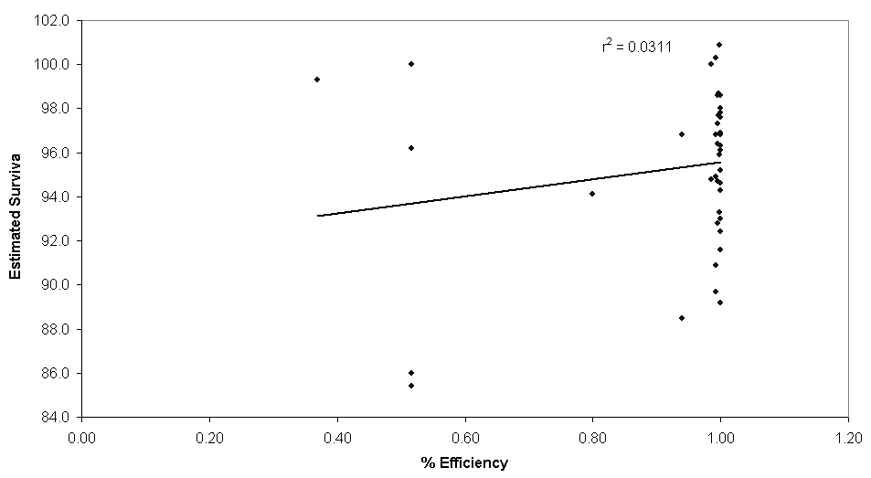

B. 2002 McNary Turbine Survival Study

The 2002 McNary turbine survival study was performed by Normandeau, Skalski, and Mid Columbia Consulting for the Corps of Engineers, Walla Walla District. This study evaluated the survival of chinook salmon smolts through unit 9 at the following four operating conditions with releases through each of the three intake bays.

- lower end of the ±1% peak efficiency range (8,000 cfs)
- upper end of the ±1% peak efficiency range (11,200 cfs)
- additional 1% beyond the upper end of the ±1% peak efficiency range (14,000 cfs)
- maximum “on cam” blade position (16,400 cfs)

The Normandeau et al study report (Mar 2003) provides the following results.

“The highest survival of chinook salmon smolts at McNary, equipped with intake guidance screens, did not exactly correspond with peak operating efficiency (11,200 cfs). In fact, the highest survival (0.983, CI=0.957 to 1.00) occurred at 14,000 cfs, an operating point beyond the peak efficiency.”

“Direct effects of passage showed little variability at the two flows tested in April and May (11,200 and 16,400 cfs). At 11,200 cfs the estimated 48-h survival probabilities were 0.93 in May and 0.955 in April; survival was virtually identical at 16,400 cfs (0.945 in April and 0.946 in May).

“The relationship between turbine operating efficiency and survival observed in the present study is in conflict with the contemporaneous hypothesis that the highest survival is correlated with peak turbine operating efficiency. The highest survival (0.983) at McNary Dam (14,000 cfs) occurred at the turbine operating beyond the 1% peak efficiency operating range (11,200 cfs). The survival at the peak turbine efficiency operating condition (11,200 cfs) was 0.028 to 0.053 lower than at 14,000 cfs. These findings at McNary Dam are similar to those recently reported from some other hydroelectric dams on the Columbia River; reanalysis of the historical data corroborates these findings as well.”

“The hypothesis that the highest survival is correlated with peak turbine operating efficiency was not supported by the results of the present study. The highest survival (0.983) occurred at a discharge higher (14,000 cfs) than at the peak (11,200 cfs) discharge (0.93 to 0.955). In fact, survival probabilities (0.944 to 0.946) at other discharges (8,000 and 16,400 cfs) were more similar to those at the peak efficiency discharge than at 14000 cfs.” (Note: Skalski et al refers to the upper end of the ±1% peak efficiency range as the “peak discharge.”)

“Estimated survival probabilities and 90% confidence intervals in April and May are summarized as follows:
 | 8,000 cfs | 11,200 cfs | 14,000 cfs | 16,400 cfs
April | 0.944 (0.917-0.977) | 0.955 (0.931-0.982) | 0.983 (0.957-1.00) | 0.945 (0.925-0.964)
May |  | 0.930 (0.90-0.97) |  | 0.946 (0.915-0.981)

Part 3. Reasons for Discontinuing the ±1% Peak Efficiency Turbine Operating Rule

A. The NMFS 2000 Biological Opinion clearly indicates that the ±1% rule is based upon the belief that the highest turbine passage survival occurs at highest efficiency. However, there is more data showing that the highest survival does not occur at peak efficiency than there is data supporting the belief that the highest turbine passage survival occurs at highest efficiency.

B. Milo Bell’s compendium, which is the main document cited in establishing the ±1% peak efficiency rule, does not appear to contain data to support the hypothesis that the highest survival occurs when operating turbines at peak efficiency. This information has been presented in Part 3 of this document.

C. Recent data indicate that high survival or even peak survival can be achieved outside of the ±1% peak efficiency range. The McNary 2002 turbine survival test and the Skalski et al article in the North American Journal of Fisheries Management have been summarized in Part 3 of this document.

D. The ±1% peak efficiency rule causes lost generation opportunities in certain hydrologic circumstances, which costs the Bonneville Power Administration and the region’s ratepayers significantly. This year, which is a relatively dry volume runoff year, approximately $5 million in generation revenues could be gained by allowing McNary Dam to operate outside of ±1% peak efficiency. The 50-year average cost of the ±1% peak efficiency rule at McNary is approximately $12 million ($ 0-26 million range) based on monthly-average studies of forces spill with and without the ±1% peak efficiency rule assuming 90% unit availability. Additional costs of the ±1% peak efficiency rule could be recovered by allowing all of the eight mainstem FCRPS projects to operate outside of 1% peak efficiency. This potential savings has not been estimated.

Table 1. Lost Generation Revenues Due to the ±1% Peak Efficiency Rule at McNary Dam.

 | 50-yr Average ( Min – Max)
Mar | $0.5 ($0.0 – 2.5)
Apr1 | $0.8 ($0.0 – 2.2)
Apr2 | $0.7 ($0.0 – 2.1)
May | $1.7 ($0.0 – 4.0)
Jun | $1.4 ($0.0 – 2.8)
Jul | $3.2 ($0.0 – 5.5)
Aug1 | $2.6 ($0.0 – 3.9)
Aug2 | $0.9 ($0.0 – 3.5)
Sep | $0.2 ($0.0 – 5.2)
Oct | $0.3 ($0.0 – 5.8)
Nov | $0.0 ($0.0 – 0.0)
Total | $12.3 ($0.0 - 26.0)

Table 2 includes information on the turbine characteristics of the eight lower Columbia and Snake River projects. This table includes an estimate of the reduced generation capacity due to the ±1% peak efficiency rule at each project.

E. Concerns about an increased turbine discharge potentially increasing debris in the screen bypass system, increasing descaling, and reducing guidance efficiency have been expressed. However, these concerns can be addressed. An increase of debris, if it does become an issue, can be handled with increased monitoring and cleaning and/or an improved VBS designs. Gatewell conditions were evaluated during the 2002 McNary test at 11,200 cfs and 16,400 cfs turbine discharge. During the test there were no descaling issues. At 11,200 cfs there were 3 mortalities and 3 descalings of the 1070 fish recaptured; at 16,400 cfs there were 2 mortalities and 2 descalings of the 1090 fish recaptured. Additionally during the test, the passage time was significantly shorter (18 hours) when the unit was operated at the higher discharge (Absalon, 2002 AFEP Presentation). Additionally, there is no data to support the assumption that guidance will be lower with increased turbine flows.

F. SimPass was used to analyze the potential risk to spring chinook of operating McNary outside of ±1% peak efficiency this year. The Simpass assumptions and results of this analysis are shown in Table 3. Table 3 also includes a sensitivity analysis of the turbine survival assumption on the project survival estimate. Based on this analysis, there appears to be little or no risk that discontinuing the ±1% peak efficiency limit will decrease McNary’ project survival. All of the scenarios analyzed have an estimate project survival of 97.5 % ± 0.3 %. Using the most recent turbine survival estimate from Normandeau’s 2003 study, the SimPass analysis shows that McNary’s project survival may slightly improve (from 97.5 to 97.7%) if operating outside of ±1% peak efficiency.
Table 2. Impacts of the ±1% Peak Efficiency Requirement on Powerhouse Capacities: Difference Between Upper End of ±1% Range and Sustained Powerhouse Capacity.

Turbine Characteristics
 |  |  | Sustained Generation Capacity |  |  |  | Generation Capacity at Upper End of ±1% Peak Efficiency Range  (fish screens in place)
Plant | # Units | Unit # | MW/Unit | Total MW | Total Plant Capacity MW | Flow rate | MW/Unit | Total MW | Total Plant Capacity MW | Flow rate | Unit Reduction | Overall Project Reduction
LWG | 3 | 1-3 | 155.0 | 465.0 | 930.0 | 21.2 | 155.0 | 465.0 | 846.3 | 21.2 | 0 | 83.7 MW
 | 3 | 4-6 | 155.0 | 465.0 |  |  | 127.1 | 381.3 |  | 17.5 | 18.0% | 9.0%
LGS | 3 | 1-3 | 155.0 | 465.0 | 930.0 | 21.7 | 155.0 | 465.0 | 837.9 | 21.7 | 0 | 92.1 MW
 | 3 | 4-6 | 155.0 | 465.0 |  |  | 124.3 | 372.9 |  | 17.5 | 19.8% | 9.9%
LMN | 3 | 1-3 | 155.0 | 465.0 | 930.0 | 21.7 | 155.0 | 465.0 | 885.0 | 21.7 | 0 | 45.0 MW
 | 3 | 4-6 | 155.0 | 465.0 |  |  | 140.0 | 420.0 |  | 19.2 | 9.7% | 4.8%
IHR | 3 | 1-3 | 103.0 | 309.0 | 690.0 | 14.4 | 101.0 | 303.0 | 678.0 | 13.9 | 1.9% | 12.0 MW
 | 3 | 4-6 | 127.0 | 381.0 |  | 18.6 | 125.0 | 375.0 |  | 16.9 | 1.6% | 1.7%
MCN | 14 | 1-14 | 80.0 | 1120.0 | 1120.0 | 15.1 | 65.8 | 921.2 | 921.2 | 12.4 | 17.8% | 198.8 MW  17.8%
JDA | 16 | 1-16 | 155.0 | 2480.0 | 2480.0 | 20.1 | 155.0 | 2480.0 | 2480.0 | 20.1 | 0 | 0
TDA | 14 | 1-14 | 90.0 | 1260.0 | 2052.0 | 14.9 | 90.0 | 1260.0 | 2052.0 | 14.9 | 0 | 0
 | 8 | 15-22 | 99.0 | 792.0 |  | 16.0 | 99.0 | 792.0 |  | 16.0 | 0
BON | 1 | 1 | 47.0 | 47.0 | 1193.5 |  | 41.0 | 41.0 | 913.2 | 12.7 | 12.8% | 280.3 MW
 | 1 | 2 | 54.5 | 54.5 |  |  | 41.0 | 41.0 |  | 12.7 | 24.8% | 23.5%
 | 6 | 3, 5, 7-10 | 60.0 | 360.0 |  |  | 41.0 | 246.0 |  | 12.7 | 31.7%
 | 2 | 4, 6 | 60.0 | 120.0 |  |  | 37.4 | 74.8 |  | 9.8 | 37.7%
 | 8 | 11-18 | 76.5 | 612.0 |  | 20.0 | 63.8 | 510.4 |  | 17.1 | 16.6%
TOTAL |  |  |  | 10325.5 | 10325.5 |  |  | 9613.6 | 9613.6 |  | 6.9 % | 711.9 MW

Table 3. Sensitivity of Juvenile Spring Chinook Passage Survival at McNary Dam to Alternative Turbine Survival Assumptions

 | Assumptions
Total river discharge | 200 kcfs
Spill survival¹ | 0.98
Bypass survival¹ | 0.98
FGE¹ | 0.83
Diel | 0.50
Spill Efficiency¹ | 1.0
 | Allow Operation Outside 1% |  |  | Maintain  1% Limit
Spill discharge (day/night) | 0/150 kcfs |  |  | 30/150 kcfs
Estimated FPE | 89.4 |  |  | 90.7

Sensitivity of Project Survival

to Turbine Survival Estimate
Turbine Survival | 0.90¹ | 0.93 | 0.95 | 0.90¹ | 0.93² | 0.95
Estimated Project Survival | 97.2 | 97.5 | 97.7 | 97.3 | 97.5 | 97.7

Part 4. References

Absolon, R.F., 2002. Evaluation of Gatewell Conditions and Turbine Passage Survival at Two Operating Conditions at McNary Dam. Presentation, U.S. Army Corps of Engineers, Anadromous Fish Evaluation Program 2002 Annual Review.

Bell, Milo C., 1981. Updated Compendium on the Success of Passage of Small Fish Through Turbines. Contract No. DACW-68-76-C-0254, U.S. Army Corps of Engineers.

Bell, Milo C., Allan C. DeLacy, Gerald J. Paulic, 1967. A Compendium on the Success of Passage of Small Fish Through Turbines. Contract No. DA-35-026-CIVENG-66-16, U.S. Army Corps of Engineers.

Eicher, G. J., Eicher Associates, 1987. Turbine-Related Fish Mortality: Review and Evaluation of Studies. Electric Power Research Institute AP-5480, Project 2694-4.

National Marine Fisheries Service, Northwest Region, 2002. Endangered Species Act – Section 7 Consultation Biological Opinion, Reinititation of Consultation on Operation of the Federal Columbia River Power System, Including the Juvenile Fish Transportation Program and 19 Bureau of Reclamation Projects in the Columbia Basin.

Normandeau Associates, 2003. Survival/Condition of Chinook Salmon Smolts Under Different Turbine Operations at McNary Dam, Columbia River. Contract No. DACW68-02-D-0002, U.S. Army Corps of Engineers.

Skalski, John R., Dilip Mathur, Paul G. Heisey, 2002. Effects of Turbine Operating Efficiency on Smolt Passage Survival. North American Journal of Fisheries Management 22:1193-1200, 2002.

NMFS 2000 Biological Opinion, D-13 and D-15; Best Professional Judgement
Normandeau 2003

